Urdu Sign Language & Speech/Text Converter Using Simple RGB Camera

**Submitted to:**

Department of Computer Sciences & IT



The University of Lahore

**Submitted by:**

|  |  |
| --- | --- |
| Muhammad Saad Qadri | Muhammad Junaid Ejaz |
| BCS02153218 | BCS02153244 |
| [Saadbutt32@gmail.com](mailto:Saadbutt32@gmail.com) | shapedprodigy@gmail.com |

**Supervised by:**

Dr. Mudasser Naseer

Associate Professor

Department of Computer Sciences & IT

# Signature Page

|  |  |  |
| --- | --- | --- |
| Muhammad Junaid Ejaz | BCS02153244 |  |
| Muhammad Saad Qadri | BCS02153218 |  |

**Approved by:**

_______________________________                   _______________________________

            Date of Submission                                                                          Advisor

Dr. Mudasser Naseer

# Abstract

We propose a Pakistan Sign Language(PSL) recognition system based on the human body key points. This duplex system will be developed to convert Urdu text into Pakistan Sign Language(PSL) and Pakistan Sign Language(PSL) into Urdu text. However, in future versions conversion from sign language will also be available in voice providing more convenience to normal person. Currently there is no dataset available for PSL, so one of the major contributions of this project is the development of dataset for PSL. We propose a system based on OpenPose, an open source toolkit for real-time multi-person key point detection. OpenPose can estimate in total 130 key points where 18 key points are from body pose, 21 key points are from each hand, and 70 key points from the face. Our recognition system is robust in different backgrounds as it only detects the human body. The system based on the human key point detection works well regardless of signer since the variance of extracted key points is negligible. Different machine learning algorithms including Support Vector Machines(SVM), K-Nearest Neighbor(KNN), Artificial Neural Network(ANN), Recurrent Neural Network(RNN) will be used for recognizing signs and will be analyzed for accuracy and performance. Animations of different PSL signs will also be made using motion capture (MO Cap) which will be used to convey the message of normal person to hearing impaired person. Moreover, the animations will also be used for interactive learning of PSL.

# Dedication

We dedicate this project to ALLAH Almighty our creator, our strong pillar, our source of inspiration, wisdom, knowledge and understanding. He has been the source of our strength throughout this program.

# Acknowledgement

The countless blessings of Allah Almighty have made this project easy for us. We present our humble gratitude for Him, for the showering of His special blessings on us. We take this opportunity to acknowledge the role of those whose endless efforts and contributions were always there when we needed them. we would like to thank our supervisor Dr. Mudasser Naseer for his precious time and considerate guidance. we would also like to thank our parents for their support that made us confident in life and to take challenges and pursue them.

Table of Contents

Signature Page i

Abstract i

Dedication i

Acknowledgement i

Chapter 1: Introduction to the Problem 1

Introduction 1

Purpose 1

Objective 1

Existing Solution 1

Proposed Solution (Gap Analysis) 1

References 1

Chapter 2: Software Requirement Specification 1

Introduction 1

1.1. Purpose 1

1.2. Scope 1

1.3. Definitions, acronyms, and abbreviations 1

1.4. References 1

1.5. Overview 1

2. Overall description 1

2.1. Product perspective 1

2.2. Product functions 1

2.3. User characteristics 1

2.4. Constraints 1

2.5. Assumptions and dependencies 1

2.6. Apportioning of requirements 1

3. Specific requirements 1

3.1. Functional Requirement 1

3.2. Non-functional Requirements 1

Chapter 3: Use Case Analysis 1

Use Case Diagram-(Level-1) 1

3.1 UC_01 (Create Account) 1

3.2 UC_02 (View Profile) 1

3.3 UC_03 (Edit Account) 1

3.4 UC_04 (Login) 1

3.5 UC_05 (Logout) 1

3.6 UC_06 (Start Saving Conversations) 1

3.7 UC_07 (Stop Saving Conversations) 1

3.8 UC_08 (View Saved Conversations) 1

3.9 UC_09 (Search Conversations) 1

3.10 UC_10 (Delete Conversations) 1

3.11 UC_11 (View Help) 1

3.12 UC_12 (Recognize Sign) 1

3.13 UC_13 (Display Recognition Output) 1

3.14 UC_14 (Play Animation) 1

3.15 UC_15 (View Recent Animations) 1

3.16 UC_16 (Play Recent Animations) 1

Chapter 4: Design 1

4.1 Architecture Diagram 1

4.2 ERD with data dictionary 1

4.2.1 Data Dictionary 1

4.3 Data Flow diagram 1

4.4 Class Diagram 1

4.5 Activity Diagrams 1

4.6 Sequence Diagrams 1

4.7 Collaboration Diagram 1

4.8 State Transition Diagram 1

4.9 Component Diagram 1

4.10 Deployment Diagram 1

# Chapter 1: Introduction to the Problem

## Introduction

In this world, there exist people who lose the hearing and speaking abilities, and sign language is the primary form of communication for them. Sign language exists in various forms for hundreds of years and as other languages, has accents and linguistic components. There are many approaches for translating and interpreting sign language to aid in communication between the signer and non-signer. The common one for example are the human sign language interpreter, voice-to-text transcription and the conventional pen and paper. Each of these method has its own pros and cons in terms of cost and convenient.

The proposed application is a dual mode application that is used for proper communication between signers and non-signers. This duplex system will be developed to convert Urdu text into Pakistan Sign Language(PSL) and Pakistan Sign Language(PSL) into Urdu text. However, in future versions conversion from sign language will also be available in voice providing more convenience to normal person. Main objective is to facilitate a large population and making hearing impaired persons, the integral part of the society. The system is based on Pakistan Sign Language (PSL) when the user performs a sign of PSL, using machine learning techniques the nature of hand gesture will be recognized and converted into corresponding text. Likewise, user will input text and corresponding animation will be shown to user.

Most of previous works used some kind of external sensors to detect gestures, but the proposed work is a dual mode, desktop based application that uses a single RGB camera to detect gestures.

## Purpose

A noticeable amount of deaf community exists in Pakistan. A detail study has been presented based upon statistical data regarding the deaf people in Pakistan [1][2]. About 3.3 million Pakistanis are suffering from different kinds of disability in which 0.24 million are impaired of hearing which approximates to 7.4% of overall disables. A very important point is that 55% of the total disabled lie in the age group from 5 -29 years. Also there exist many sign language interpreters that are in English or follow ASL (American Sign Language) but there’s not one interpreter which follows PSL (Pakistan Sign Language) or that is made for Urdu language.

Consider a deaf and mute person who wants to: Place an order at restaurant, want to ask for directions, want to take a class in university, Need help in disaster situations. He would not be able to do so. To enable him to get out these situations a system is required that can act as an interpreter between the signer and the non-signer.

## Objective

The aim of the project is to find a better method to bridge the communication of Pakistan Sign Language(PSL) by developing a Sign Language system which is easy to use and helps in communication between hearing-impaired people and normal people in various situations. The system is expected to have the ability to translate from words and alphabets that are provided manually into an animation that demonstrates a sign language gesture. The main objective of this system is to provide user with following:

* Provide a mean for communication between signers and non-signers.
* Make the system cheap by using a single RGB camera and eliminating the need for specialized sensors.
* Make social interactions easier for hearing impaired people of society.
* Make the system more accurate and easy to use.
* Make the learning of sign language easier.

## Existing Solution

Research in the sign language system has two well-known approaches, image processing and data Glove. Worldwide efforts have been made to aid the deaf community in communicating with non-signers. Some of the known solutions are:

* A research based development of a sign language recognition system using a data glove is proposed by Nicholas Born [4]. In this approach, detection of hand is eliminated by the sensor glove consists of flex sensor an accelerometer.
* Most recently Muhammad Wasim et al [5] used leap motion sensor to develop a system to communicate in sign language. They were able to detect some signs with the accuracy level of up to 100%.
* Another approach used by A. Muhammad at el [3] is to track skeleton using Kinect sensor. The Accuracy of system is not known.
* Another approach using data glove but this time the colored one is proposed by Sumaira et al [6]. They have used a fuzzy classifier to recognize the signs/gestures performed by the deaf. Their algorithm uses the angle between fingertip and joint for classification of gesture. Their dataset was based on Urdu alphabets of Pakistan sign language. They have achieved an overall accuracy of 95% as 35 out of 37 alphabets were recognized correctly. Again, the cost of color data glove, recognition of single hand gestures and static gestures are the limitations of their system.
* Another work for reducing communication gap between the deaf and normal is done by Asif Ali [7]. They have proposed a system which takes input in both forms text and image of sign and convert it into other form. They have performed this for Urdu alphabets of PSL using Haar classifier. They have used a simple RGB camera for this purpose. However, they have not specifically mentioned the size and nature of dataset used for experimentation. The accuracy rate of developed system is also missing.

Major drawback of Motion sensor based system (i.e. Microsoft Kinect) is that they cannot work properly in sunlight. They are expensive and not portable.

## Proposed Solution (Gap Analysis)

The proposed Sign Language Interpreter would be a two ways communication for both the signer and the non-signer. We propose a sign recognition system based on the human key points that are estimated by pre-existing libraries. Here we develop our system based on OpenPose, an open source toolkit for real-time multi-person key point detection. OpenPose can estimate in total 130 key points where 18 key points are from body pose, 21 key points are from each hand, and 70 key points from a face.

There is no dataset available for PSL. So one of the major contributions of this project is the development of dataset for PSL. Different machine learning algorithms including Support Vector Machines(SVM), K-Nearest Neighbor(KNN), Artificial Neural Network(ANN), Recurrent Neural Network(RNN) will be used for recognizing signs and will be analyzed for accuracy and performance. Machine Learning libraries like scikit-learn, tensorflow and keras will also be used.

Animations of different PSL signs will be made using motion capture (MO Cap) which will be used to convey the message of normal person to hearing impaired person. Moreover, the animations will also be used for interactive learning of PSL.

First, our recognition system is robust in different backgrounds as it only detects the human body. Second, the system based on the human key point detection works well regardless of signer since the variance of extracted key points is negligible. Moreover, we normalize the feature vector using the mean and standard deviation of the vector to reduce the variance of the data. Third, our system can enjoy the benefits of the improvement on the key point detection system which has a great potential in the future because of its versatility. For instance, the human key point detection system can be used for recognizing different human behaviors and actions given that the relevant dataset is secured. Lastly, the use of high level features is necessary when the scale of the dataset is not large enough. In the case of sign language dataset, it is more difficult to collect than the other dataset as many professional signers should be utilized for recording sign language videos of high quality.

## References

1. Statistics, D. (2015). Deaf Statistics. Pakistan Association of Deaf. Retrieved 24 October 2018, from <http://padeaf.org/deaf-statistic/>
2. Waqar, K. (2014). Disability: Situation in Pakistan (1st ed.). Karachi: Right to Education Pakistan. Retrieved from http://www.itacec.org/document/gaw/gaw2014/2.%20Disability%20Pages%202.pdf
3. Rini Akmeliawatil, Melanie PO-Leen Ooi et al,” RealTime Malaysian Sign Language Translation using Color Segmentation and Neural Network. Instrumentation and Measurement Technology Conference Warsaw”, Poland.IEEE.1-6, 2007.
4. Nicholas Born, “Senior Project Sign Language Glove”, ELECTRICAL ENGINEERING DEPARTMENT. California Polytechnic State University 1-49, 2010.
5. M. Wasim, Abdulbasit Shaikh, A.A Siddiqui. Communicator for Hearing-Impaired Persons using Pakistan Sign Language (PSL). International Journal of Advanced Computer Science and Applications, Vol. 9, No. 5, 2018
6. Kausar, S., Javed, M. Y., & Sohail, S. (2008, August). Recognition of gestures in Pakistani sign language using fuzzy classifier. In Proceedings of the 8th conference on Signal processing, computational geometry and artificial vision (pp. 101-105). World Scientific and Engineering Academy and Society (WSEAS).
7. Ali, S. A. Detection of Urdu Sign Language using Harr Algorithms.

# Chapter 2: Software Requirement Specification

## Introduction

### Purpose

The purpose of this document is to present a detailed description of Sign Language interpreter. It will explain the purpose and features of the system, the interfaces of the system, what the system will do and the constraints under which it must operate. This document is intended for both the stakeholders and the developers of the system.

### Scope

This software system will be a desktop application for converting Urdu sign language into text and vice-versa. This system will be used by people with impaired hearing and the normal persons so they can easily communicate with each other, without any specialized equipment. By minimizing the cost and availability issues and maximizing the output, the system will meet users need while remaining easy to understand and use.

The system is designed to allow the hearing impaired person to easily communicate with other in need of emergency. The animations will be provided of certain alphabets and words to instruct normal person.

### Definitions, acronyms, and abbreviations

|  |  |
| --- | --- |
| **Term/Abbreviation** | **Description** |
| OPENPOSE | This is a convolutional neural network key point detector of human body. [1] |
| PYTHON | Python is an interpreted, high-level, general-purpose programming language. |
| PSL | Pakistan Sign Language. |
| RGB CAMERA | The human eye is sensitive to Red, Green, and Blue so these cameras recreate exactly what our eyes see. |
| ELECTRON | Electron allows for the development of desktop GUI applications using front and back end components originally developed for web applications. |
| SVM | A **Support Vector Machine** (**SVM**) is a discriminative classifier formally defined by a separating hyperplane. In other words, given labeled training data (supervised learning), the algorithm outputs an optimal hyperplane which categorizes new examples.[2] |
| KNN | K nearest neighbors is a simple algorithm that stores all available cases and classifies new cases based on a similarity measure (e.g., distance functions).[3][4] |
| ANN | Artificial Neural networks (**ANN**) or neural networks are computational algorithms. It intended to simulate the behavior of biological systems composed of “neurons”. ANNs are computational models inspired by an animal's central nervous systems. It is capable of **machine learning** as well as pattern recognition.[5] |
| TensorFlow | TensorFlow [6] is an interface for expressing machine learning algorithms, and an implementation for executing such algorithms. A computation expressed using TensorFlow can be executed with little or no change on a wide variety of heterogeneous systems, ranging from mobile devices such as phones and tablets up to large-scale distributed systems of hundreds of machines and thousands of computational devices such as GPU cards. |
| RNN | A **recurrent neural network** (**RNN**) is a class of artificial neural network where connections between nodes form a directed graph along a sequence. This allows it to exhibit temporal dynamic behavior for a time sequence. Unlike feedforward neural networks, RNNs can use their internal state (memory) to process sequences of inputs. |
| SD | Standard Deviation is a quantity expressing by how much the members of a group differ from the mean value for the group. |
| JSON | JavaScript Object Notation (JSON) is a lightweight format for storing and transporting data. |

### References

1. Zhe Cao, Yaser Sheikh et al,” Realtime Multi-Person 2D Pose Estimation using Part Affinity Fields”, arXiv:1611.08050v2 [cs.CV] 14 Apr 2017.
2. Avinash Navlani,” Support Vector Machines with Scikit-learn”, 12 July 2018. available at “https://www.datacamp.com/community/tutorials/svm-classification-scikit-learn-python”
3. Avinash Navlani,” KNN Classification using Scikit-learn”, 2 Aug 2018. available at “https://www.datacamp.com/community/tutorials/k-nearest-neighbor-classification-scikit-learn”
4. Yun-lei Cai et al “A KNN Research Paper Classification Method Based on Shared Nearest Neighbor”, (Proceedings of NTCIR-8 Workshop Meeting, June 15–18, 2010, Tokyo, Japan).
5. Ms. Sonali. B. Maind et al,” Research Paper on Basic of Artificial Neural Network”, (International Journal on Recent and Innovation Trends in Computing and Communication ISSN: 2321-8169 Volume: 2 Issue: 1).
6. Mart´ın Abadi, Ashish Agarwal et al,” TensorFlow: Large-Scale Machine Learning on Heterogeneous Distributed Systems”, (Preliminary White Paper, November 9, 2015)

### Overview

The next chapter, the Overall Description section, of this document gives an overview of the functionality of the product. It describes the informal requirements and is used to establish a context for the technical requirements specification in the next chapter.

The third chapter, Requirements Specification section, of this document is written primarily for the developers and describes in technical terms the details of the functionality of the product.

Both sections of the document describe the same software product in its entirety, but are intended for different audiences and thus use different language.

## Overall description

### Product perspective

There exist people who lose the hearing and speaking abilities and a sign language is the primary form of communication for them. The proposed application is a dual mode application that is used for proper communication between signers and non-signers. This duplex system is developed through conversion from the text in simple Urdu into hand gestures and vice versa. When the user input gestures in to the application, using machine learning techniques the nature of hand gesture will be recognized and converted into corresponding text. Likewise, user will input text and animation of that text will be shown to user.

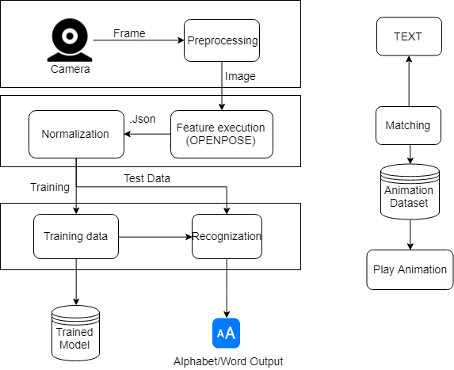

#### User interfaces

##### Main Screen

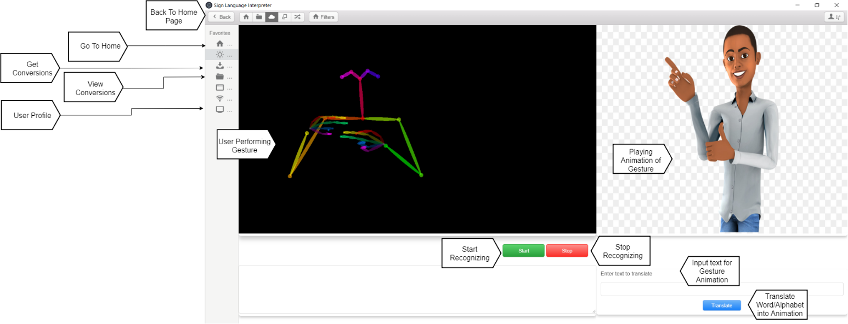

##### Conversations

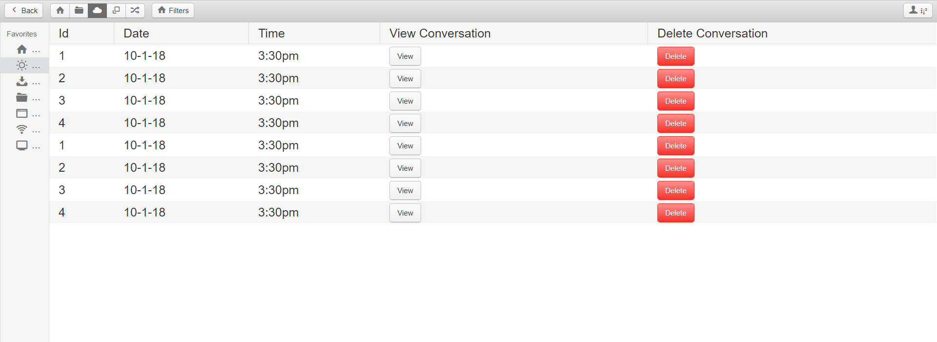

##### Animations

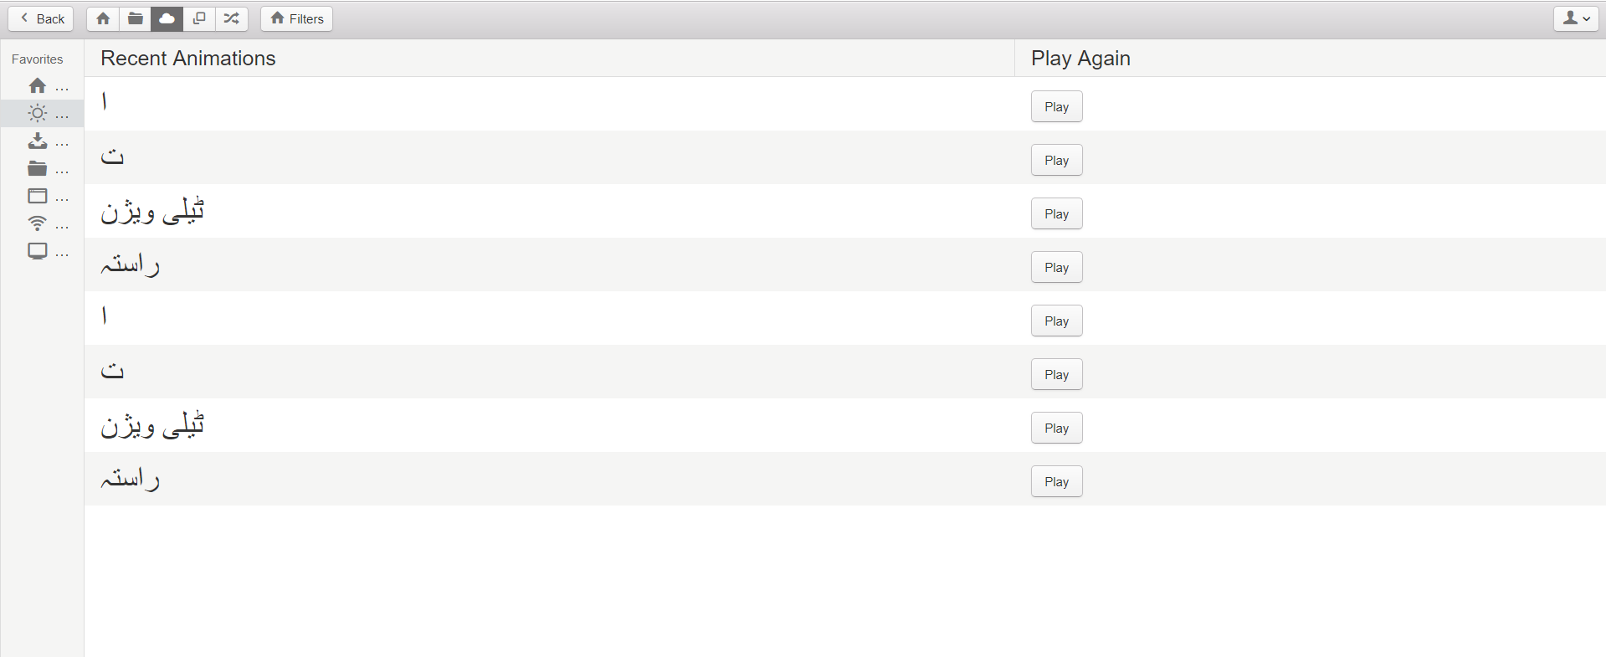

#### Hardware interfaces

There are no extraordinary hardware interfaces for the system. Any computer with working webcam and graphic card installed will work.

#### Software interfaces

The software will operate in Windows 10 environment.

#### Communications Interfaces

There are no communications interfaces for the system.

#### Memory

* At least 4Gb of Ram is needed for the system

### Product functions

The main purpose of our application is to aid communication between signer and non-signer. The signer will perform a gesture in front of RGB camera which will detect the hand position and it will create an output as text corresponding to performed gesture. The non-signer will put text in text-field which will be converted into an animation of hand gesture.

#### 2.2.1 Create Account

|  |  |  |  |  |
| --- | --- | --- | --- | --- |
| ID: | FR_01 | | | |
| Name: | Create Account | | | |
| Description | Input | Output | Requirements | Basic Work Flow |
| Enter details to create account | Name, Username, Password etc. | Account created | Correct Input | Enter correct information and click submit button System save the record in database |

#### 2.2.2 View Profile

|  |  |  |  |  |
| --- | --- | --- | --- | --- |
| ID: | FR_02 | | | |
| Name: | View Profile | | | |
| Description | Input | Output | Requirements | Basic Work Flow |
| Click Profile Icon to View Account Information | Click Profile Icon | New page with account information | User Logged in | Click Profile Icon, Select View Profile from Dropdown,  System shows the profile in new page |

#### 2.2.3 Edit Account

|  |  |  |  |  |
| --- | --- | --- | --- | --- |
| ID: | FR_03 | | | |
| Name: | Update Account | | | |
| Description | Input | Output | Requirements | Basic Work Flow |
| Edit user account | Name, Username, Password etc. | Account updated | User Logged in | Enter correct information and click update button System save the updated record in database |

#### 2.2.4 Login

|  |  |  |  |  |
| --- | --- | --- | --- | --- |
| ID: | FR_04 | | | |
| Name: | Login | | | |
| Description | Input | Output | Requirements | Basic Work Flow |
| Enter username and password | Username, Password | Logged in | Correct Username and Password | Enter correct information and click Login button System login the user |

#### 2.2.5 Logout

|  |  |  |  |  |
| --- | --- | --- | --- | --- |
| ID: | FR_05 | | | |
| Name: | Logout | | | |
| Description | Input | Output | Requirements | Basic Work Flow |
| Logout from the system | Click Logout Button | Logged out | Logged in | Click Logout button to Logout from system |

#### 2.2.6 Start Saving Conversions

|  |  |  |  |  |
| --- | --- | --- | --- | --- |
| ID: | FR_11 | | | |
| Name: | Start Saving Conversions | | | |
| Description | Input | Output | Requirements | Basic Work Flow |
| Save conversations between normal and deaf people | Click save conversion button | Conversations starts saving | Logged in | Click save conversion button, System saves the conversations in database |

#### 2.2.7 Stop Saving Conversions

|  |  |  |  |  |
| --- | --- | --- | --- | --- |
| ID: | FR_12 | | | |
| Name: | Stop Saving Conversions | | | |
| Description | Input | Output | Requirements | Basic Work Flow |
| Stop saving conversations between normal and deaf people | Click Stop saving conversion button | Conversations stops saving | Logged in | Click Stop saving conversion button, System stops saving the conversations |

#### 2.2.8 View Saved Conversions

|  |  |  |  |  |
| --- | --- | --- | --- | --- |
| ID: | FR_13 | | | |
| Name: | View Saved Conversions | | | |
| Description | Input | Output | Requirements | Basic Work Flow |
| View Saved conversations between normal and deaf people | Click View conversion button | New Page with Conversations | Logged in | Click View conversion button, System shows saved conversations  In new page |

#### 2.2.9 Search Conversions

|  |  |  |  |  |
| --- | --- | --- | --- | --- |
| ID: | FR_14 | | | |
| Name: | Search Conversions | | | |
| Description | Input | Output | Requirements | Basic Work Flow |
| Search specific conversation | Date, time | Relative Conversations | Logged in | Enter Date and Time, System shows Relative  Conversations |

#### 2.2.10 Delete Conversions

|  |  |  |  |  |
| --- | --- | --- | --- | --- |
| ID: | FR_15 | | | |
| Name: | Delete Conversions | | | |
| Description | Input | Output | Requirements | Basic Work Flow |
| Delete specific Conversation | Conversation id | Conversation deleted | Logged in | Select specific conversation, click delete button, system deletes the conversation from database |

#### 2.2.11 View Help

|  |  |  |  |  |
| --- | --- | --- | --- | --- |
| ID: | FR_16 | | | |
| Name: | View Help | | | |
| Description | Input | Output | Requirements | Basic Work Flow |
| View Help Document | Click Help Button | Help document shown in new page | Logged in | click help button System shows help document |

#### 2.2.12 Recognize Sign

|  |  |  |  |  |
| --- | --- | --- | --- | --- |
| ID: | FR_17 | | | |
| Name: | Recognize Sign | | | |
| Description | Input | Output | Requirements | Basic Work Flow |
| Recognize specific sign for interpreting it | Camera | Sign Recognized | Logged in, camera active | Sign in front of camera, system recognizes the sign |

#### 2.2.13 Display Recognition output

|  |  |  |  |  |
| --- | --- | --- | --- | --- |
| ID: | FR_18 | | | |
| Name: | Display Recognized Sign | | | |
| Description | Input | Output | Requirements | Basic Work Flow |
| Display results of recognitions | camera | Text displayed | Logged in , camera active, sign recognized | system recognizes the sign and displays output |

#### 2.2.14 Play Animation

|  |  |  |  |  |
| --- | --- | --- | --- | --- |
| ID: | FR_20 | | | |
| Name: | Play Animation | | | |
| Description | Input | Output | Requirements | Basic Work Flow |
| Play animations of specific user input | System generated | Animation played | Logged in, user input matched animation | System plays animation of specific user input if it matches animation stored in database |

#### 2.2.15 View Recent Animations

|  |  |  |  |  |
| --- | --- | --- | --- | --- |
| ID: | FR_22 | | | |
| Name: | View Recent Animations | | | |
| Description | Input | Output | Requirements | Basic Work Flow |
| View recently played animations | Click recent animations button | Recent animations showed in new page | Logged in | click recent animations button System shows recent animations in new page |

#### 2.2.16 Play Recent Animation

|  |  |  |  |  |
| --- | --- | --- | --- | --- |
| ID: | FR_23 | | | |
| Name: | Play Recent Animation | | | |
| Description | Input | Output | Requirements | Basic Work Flow |
| Play recently played animations again | Recent animation id | Recent animation played | Logged in | Select recent animation, click play button, System plays animations |

### User characteristics

|  |  |
| --- | --- |
| **Name** | **Description** |
| Deaf User | Person who has lost his hearing naturally or unnaturally is called a deaf person. |
| Normal User | A normal person (without hearing or speaking disability) who wants to communicate with the deaf person. |

### Constraints

The current constraints on the project are related to hardware. At present, a working webcam, Core i3, 4 GB RAM, Windows 10.

### Assumptions and dependencies

A number of factors that may affect the requirements specified in the SRS include:

* If the person does not perform correct gesture of required alphabet/word the system will not produce desired output.
* The hand of the user should be clearly visible to camera to maximize the efficiency.
* The normal user should input the text they want animation in Urdu to avoid any error.

### Apportioning of requirements

* The system will start detecting dynamic signs which are mostly used in words or sentences.
* Now the system is only compatible with Desktop but it will be with android and iOS in future versions.
* The dataset to detect more words will be added gradually.
* Text-to speech and speech to text will also be included

## Specific requirements

### Functional Requirement

#### Sign Language Recognition**:**

The application must recognize signs of the deaf user using the camera’s inputs.

#### Literal translation**:**

The application must show on the screen the word or the idea that refers to the user movement detected.

#### Animations**:**

The application must play animations of inputs by normal user.

#### Store Conversations**:**

The application must store conversations between users.

#### Interactive learning**:**

The application must provide an interface for interactive learning of PSL.

### Non-functional Requirements

#### Usability

* There will be two user types – the normal user and the hearing impaired user – each of which will have its own corresponding interface.
* The minimal requirement what a normal user can do is learn gestures or type a word/alphabet which can be converted into gesture.
* The minimal requirement what a hearing impaired user can do is perform and learn gestures.

#### Reliability

* The system must function under any given circumstances.
* There can be a maximum of 1 bug/KLOC.
* In case of bad gesture recognition, the system will give appropriate error.

#### Performance

* The recognition process will be done in real time. (3 seconds maximum)
* The maximum response time to get the gesture animation will be 3 seconds.

#### Design Constraints

* The design of the system will be made to cater both normal and people with hearing impaired.
* Most of the coding will be done in Python.
* User can get one gesture animation at a time.

#### Portability

* The system will be easily available and should be portable for both users.

#### Maintainability

* The system will be regularly tested for any types of glitches and errors which can affect its efficiency.
* It will be regularly updated to prevent any virus.

#### License Agreement

* It will be released under a GPL license and will be open-source.

# Chapter 3: Use Case Analysis

## Use Case Diagram-(Level-1)

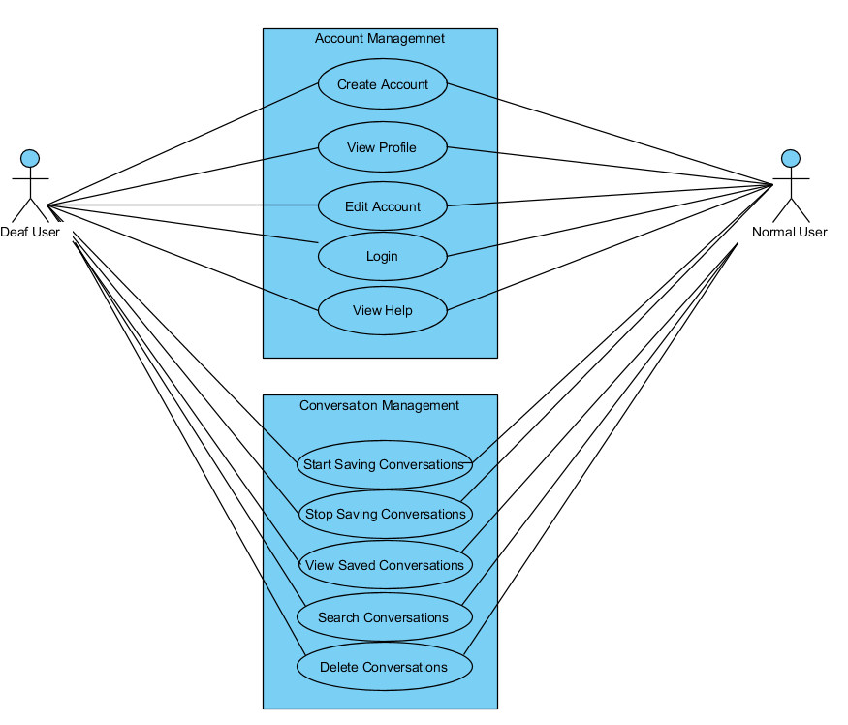

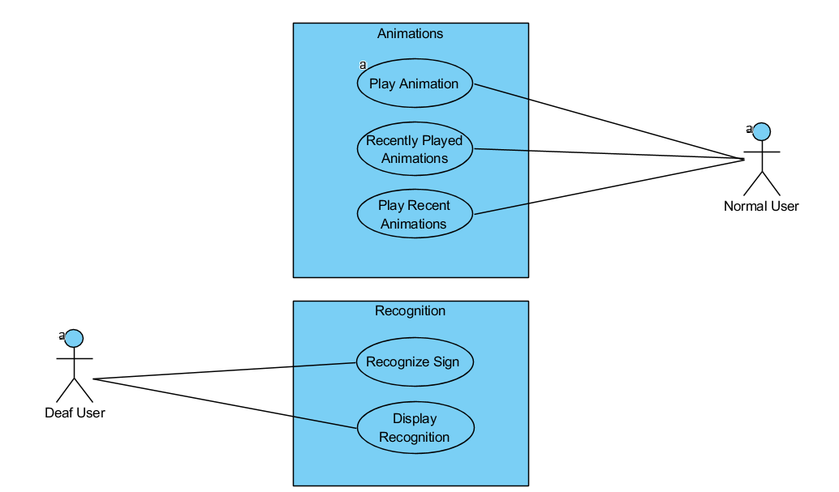

## 3.1 UC_01 (Create Account)

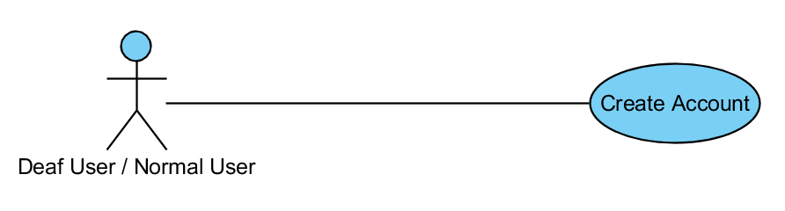

|  |  |  |
| --- | --- | --- |
| Use Case ID | UC_01 | |
| Use Case Name | Create Account | |
| Description | Enter details to  create account | |
| Primary Actor | Deaf User, Normal User | |
| Secondary Actor | None | |
| Pre-Condition | Username does not exists | |
| Post-Condition | Account Created | |
| Basic Flow | Actor Action | System Action |
|  | Enter correct information and  click submit button | System saves the  record in database and log user in system |
| Alternate Flow | If user input incorrect information system gives error and prompt user to enter information again | |

## 3.2 UC_02 (View Profile)

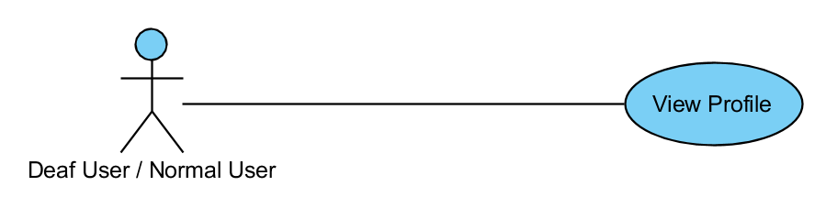

|  |  |  |
| --- | --- | --- |
| Use Case ID | UC_02 | |
| Use Case Name | View Profile | |
| Description | Click Profile Icon to View Account Information | |
| Primary Actor | Deaf User, Normal User | |
| Secondary Actor | None | |
| Pre-Condition | User Logged in | |
| Post-Condition | New page with account information | |
| Basic Flow | Actor Action | System Action |
|  | Click Profile Icon, Select View Profile from Dropdown | System shows the profile in new page |
| Alternate Flow | None | |

## 3.3 UC_03 (Edit Account)

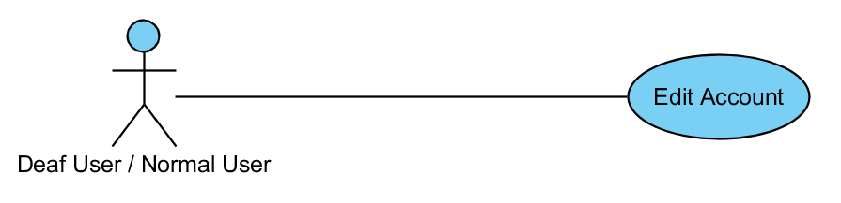

|  |  |  |
| --- | --- | --- |
| Use Case ID | UC_03 | |
| Use Case Name | Edit Account | |
| Description | Edit user account | |
| Primary Actor | Deaf User, Normal User | |
| Secondary Actor | None | |
| Pre-Condition | User Logged in | |
| Post-Condition | Account updated | |
| Basic Flow | Actor Action | System Action |
|  | Enter correct information and click update button | System save the updated record in database |
| Alternate Flow | If user input incorrect information system gives error and prompt user to enter information again | |

## 3.4 UC_04 (Login)

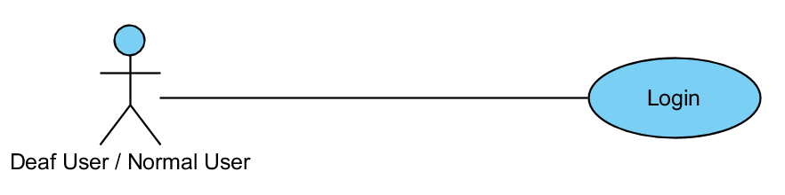

|  |  |  |
| --- | --- | --- |
| Use Case ID | UC_04 | |
| Use Case Name | Login | |
| Description | Enter username and password to login | |
| Primary Actor | Deaf User, Normal User | |
| Secondary Actor | None | |
| Pre-Condition | Correct Username and Password | |
| Post-Condition | Logged in | |
| Basic Flow | Actor Action | System Action |
|  | Enter correct information and click Login button | System login the user |
| Alternate Flow | If user input incorrect information system gives error and prompt user to enter information again | |

## 3.5 UC_05 (Logout)

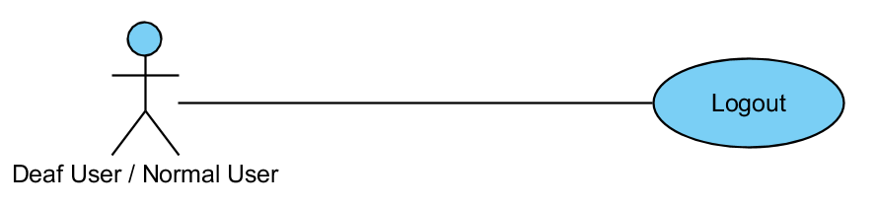

|  |  |  |
| --- | --- | --- |
| Use Case ID | UC_05 | |
| Use Case Name | Logout | |
| Description | Logout from the system | |
| Primary Actor | Deaf User, Normal User | |
| Secondary Actor | None | |
| Pre-Condition | User Logged in | |
| Post-Condition | Logged out | |
| Basic Flow | Actor Action | System Action |
|  | Click Logout button | Logout from system |
| Alternate Flow | None | |

## 3.6 UC_06 (Start Saving Conversations)

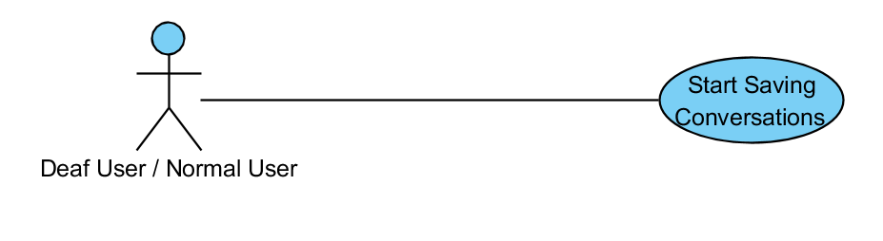

|  |  |  |
| --- | --- | --- |
| Use Case ID | UC_06 | |
| Use Case Name | Start Saving Conversations | |
| Description | Save conversations between normal and deaf people | |
| Primary Actor | Deaf User, Normal User | |
| Secondary Actor | None | |
| Pre-Condition | User Logged in | |
| Post-Condition | Conversations starts saving | |
| Basic Flow | Actor Action | System Action |
|  | Click save conversion button | System saves the conversations in database |
| Alternate Flow | None | |

## 3.7 UC_07 (Stop Saving Conversations)

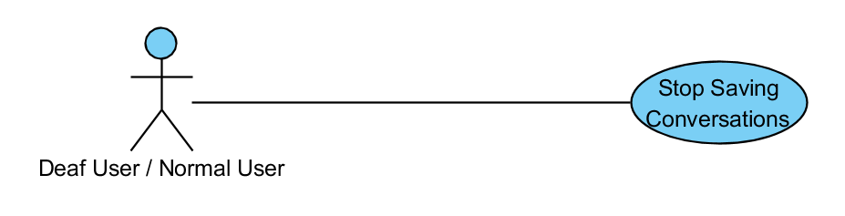

|  |  |  |
| --- | --- | --- |
| Use Case ID | UC_07 | |
| Use Case Name | Stop saving Conversations | |
| Description | Stop saving conversations between normal and deaf people | |
| Primary Actor | Deaf User, Normal User | |
| Secondary Actor | None | |
| Pre-Condition | User Logged in | |
| Post-Condition | Conversations stops saving | |
| Basic Flow | Actor Action | System Action |
|  | Click Stop saving conversion button | System stops saving the conversations |
| Alternate Flow | None | |

## 3.8 UC_08 (View Saved Conversations)

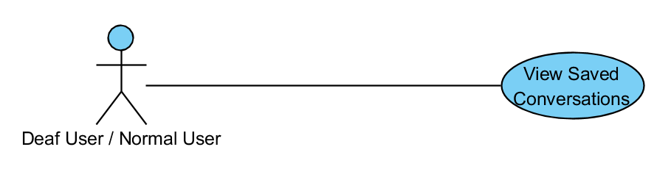

|  |  |  |
| --- | --- | --- |
| Use Case ID | UC_08 | |
| Use Case Name | View Saved Conversations | |
| Description | View Saved conversations between normal and deaf people | |
| Primary Actor | Deaf User, Normal User | |
| Secondary Actor | None | |
| Pre-Condition | User Logged in | |
| Post-Condition | New Page with Conversations | |
| Basic Flow | Actor Action | System Action |
|  | Click View conversion button | System shows saved conversations in new page |
| Alternate Flow | Display empty page if there is no record of conversations. | |

## 3.9 UC_09 (Search Conversations)

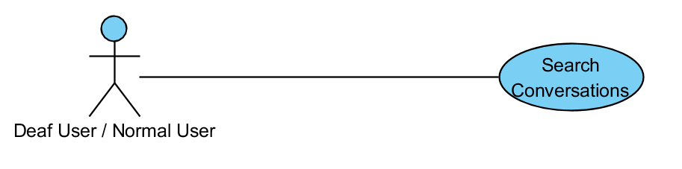

|  |  |  |
| --- | --- | --- |
| Use Case ID | UC_09 | |
| Use Case Name | Search Conversations | |
| Description | Search specific conversation | |
| Primary Actor | Deaf User, Normal User | |
| Secondary Actor | None | |
| Pre-Condition | User Logged in | |
| Post-Condition | New Page with Conversations | |
| Basic Flow | Actor Action | System Action |
|  | Enter Date and Time | System shows relative conversations |
| Alternate Flow | Show no result if there is no result for search | |

## 3.10 UC_10 (Delete Conversations)

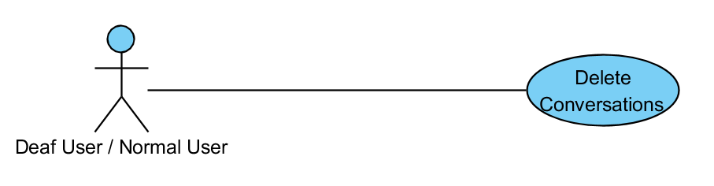

|  |  |  |
| --- | --- | --- |
| Use Case ID | UC_10 | |
| Use Case Name | Delete Conversations | |
| Description | Delete specific Conversation | |
| Primary Actor | Deaf User, Normal User | |
| Secondary Actor | None | |
| Pre-Condition | User Logged in | |
| Post-Condition | Conversation deleted | |
| Basic Flow | Actor Action | System Action |
|  | Select specific conversation, click delete button | system deletes the conversation from database |
| Alternate Flow | None | |

## 3.11 UC_11 (View Help)

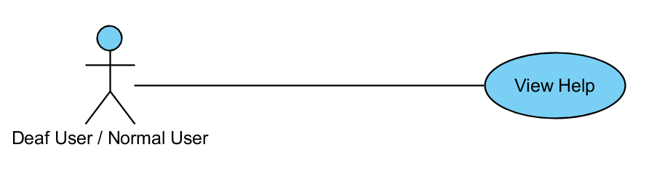

|  |  |  |
| --- | --- | --- |
| Use Case ID | UC_11 | |
| Use Case Name | View Help | |
| Description | View Help Document | |
| Primary Actor | Deaf User, Normal User | |
| Secondary Actor | None | |
| Pre-Condition | User Logged in | |
| Post-Condition | Help document shown in new page | |
| Basic Flow | Actor Action | System Action |
|  | click help button | System shows help document |
| Alternate Flow | None | |

## 3.12 UC_12 (Recognize Sign)

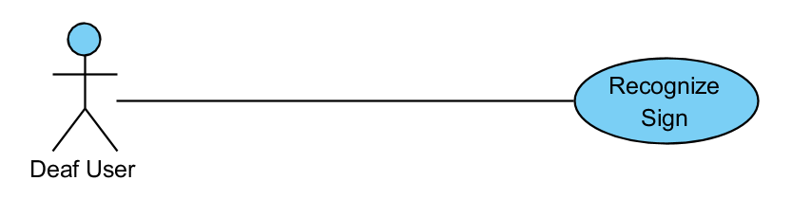

|  |  |  |
| --- | --- | --- |
| Use Case ID | UC_12 | |
| Use Case Name | Recognize Sign | |
| Description | Recognize specific sign for interpreting it | |
| Primary Actor | Deaf User | |
| Secondary Actor | None | |
| Pre-Condition | Logged in, camera active, recognizing | |
| Post-Condition | Sign Recognized | |
| Basic Flow | Actor Action | System Action |
|  | Sign in front of camera | system recognizes the sign |
| Alternate Flow | None | |

## 3.13 UC_13 (Display Recognition Output)

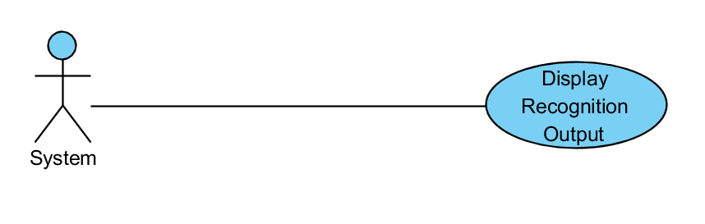

|  |  |  |
| --- | --- | --- |
| Use Case ID | UC_13 | |
| Use Case Name | Display Recognition Output | |
| Description | Display results of recognitions | |
| Primary Actor | System | |
| Secondary Actor | None | |
| Pre-Condition | Logged in , camera active, sign recognized | |
| Post-Condition | Text displayed | |
| Basic Flow | Actor Action | System Action |
|  | System Generated | system recognizes the sign and displays output |
| Alternate Flow | None | |

## 3.14 UC_14 (Play Animation)

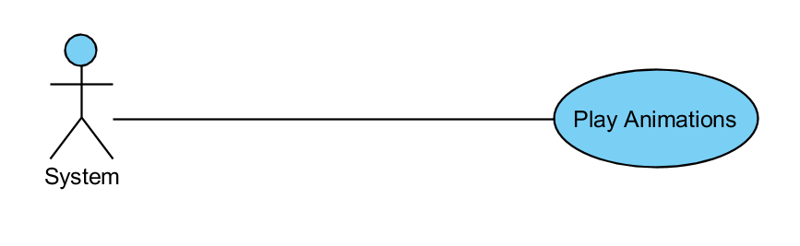

|  |  |  |
| --- | --- | --- |
| Use Case ID | UC_14 | |
| Use Case Name | Play Animation | |
| Description | Play animations of specific user input | |
| Primary Actor | System | |
| Secondary Actor |  | |
| Pre-Condition | User Logged in | |
| Post-Condition | Animation played | |
| Basic Flow | Actor Action | System Action |
|  | System generated | System plays animation of specific user input if it matches animation stored in database |
| Alternate Flow | None | |

## 3.15 UC_15 (View Recent Animations)

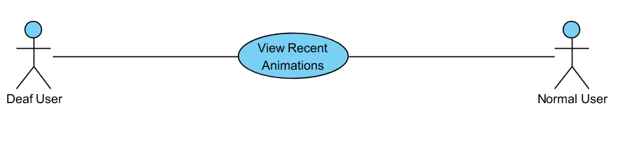

|  |  |  |
| --- | --- | --- |
| Use Case ID | UC_15 | |
| Use Case Name | View Recent Animations | |
| Description | View recently played animations | |
| Primary Actor | Deaf User | |
| Secondary Actor | Normal User | |
| Pre-Condition | User Logged in | |
| Post-Condition | Recent animations showed in new page | |
| Basic Flow | Actor Action | System Action |
|  | click recent animations button | System shows recent animations in new page |
| Alternate Flow | Shows empty page if no animations were played previously. | |

## 3.16 UC_16 (Play Recent Animations)

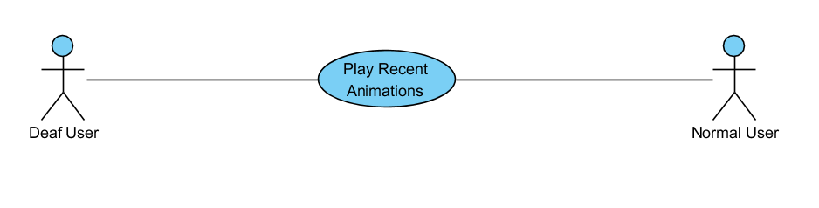

|  |  |  |
| --- | --- | --- |
| Use Case ID | UC_16 | |
| Use Case Name | Play Recent Animation | |
| Description | Play recently played animations again | |
| Primary Actor | Deaf User | |
| Secondary Actor | Normal User | |
| Pre-Condition | User Logged in | |
| Post-Condition | Recent animation played | |
| Basic Flow | Actor Action | System Action |
|  | Select recent animation, click play button, | System plays animations |
| Alternate Flow | None | |

# Chapter 4: Design

## Architecture Diagram

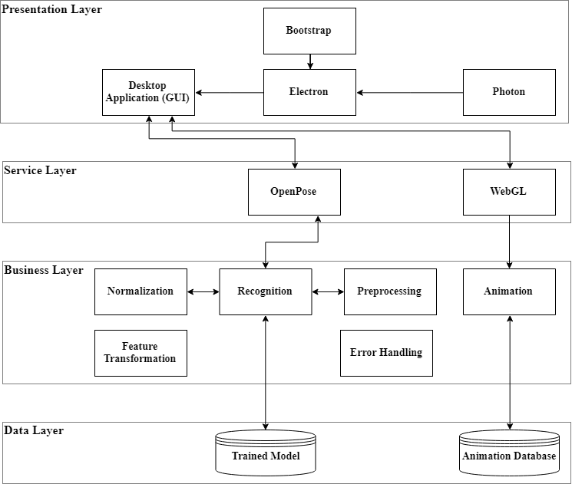

## ERD with data dictionary

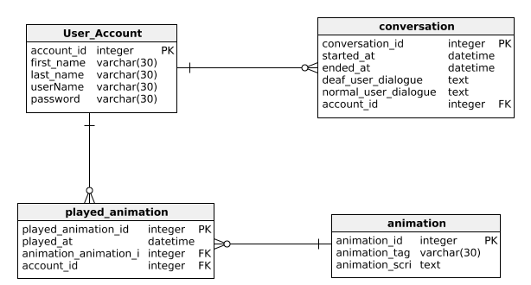

### 4.2.1 Data Dictionary

#### Entity User_Account

To store the information of user accounts.

|  |  |  |  |
| --- | --- | --- | --- |
| **Column name** | **Type** | **Properties** | **Description** |
| account_id | integer | PK | Unique number id for identifying user account. |
| first_name | varchar(30) |  | First name for user. |
| last_name | varchar(30) |  | Last name for user. |
| userName | varchar(30) |  | UserName for identifying user account by name |
| password | varchar(30) |  | Password for account security |

#### Entity Conversation

Used to store conversations between hearing impaired and normal person.

|  |  |  |  |
| --- | --- | --- | --- |
| **Column name** | **Type** | **Properties** | **Description** |
| conversation_id | integer | PK | For unique identification of conservations |
| started_at | datetime |  | Start time of conversation |
| ended_at | datetime |  | End time of conversation |
| deaf_user_dialogue | text |  | Dialogues of deaf user |
| normal_user_dialogue | text |  | Dialogues of normal user |
| account_id | integer | FK | Reference to user account for identification of user participating in conversation. |

#### Entity Animation

Used to store information about animations.

|  |  |  |  |
| --- | --- | --- | --- |
| **Column name** | **Type** | **Properties** | **Description** |
| animation_id | integer | PK | For unique identification of animations |
| animation_tag | varchar(30) |  | Tag associated with each element describing the nature of animation |
| animation_script | text |  | Python script for animating the avatar |

#### Entity played_animation

Used to store information about recently played animations.

|  |  |  |  |
| --- | --- | --- | --- |
| **Column name** | **Type** | **Properties** | **Description** |
| played_animation_id | integer | PK | For unique identification of recently played animations |
| played_at | datetime |  | Date and time at which animation was played |
| animation_animation_id | integer | FK | Reference to identify animation by id |
| account_id | integer | FK | Reference to identify the user who played the animation |

## Data Flow diagram

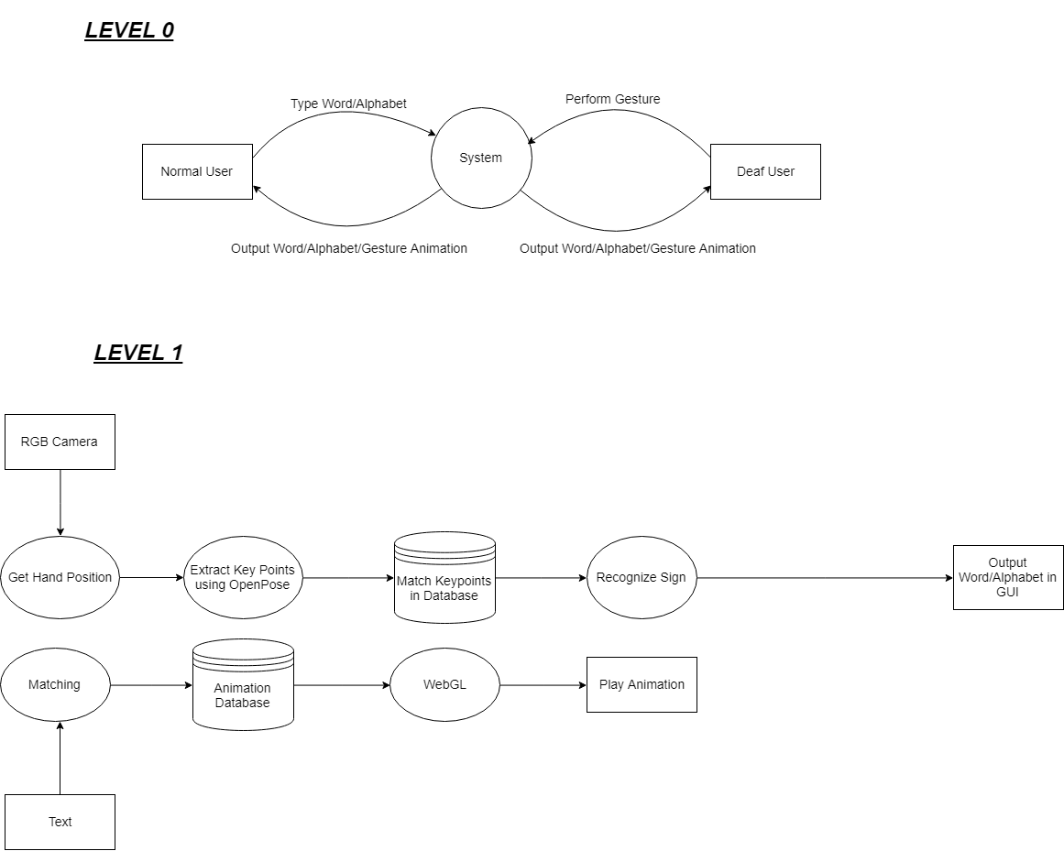

## Class Diagram

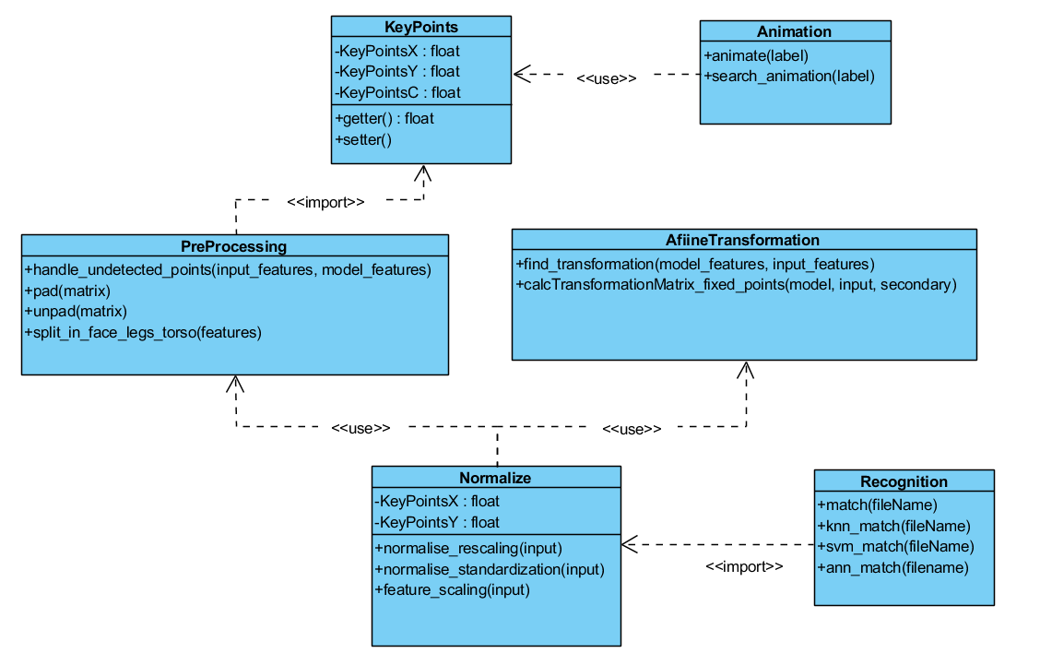

## Activity Diagrams

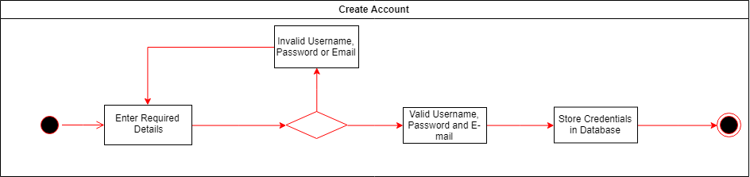

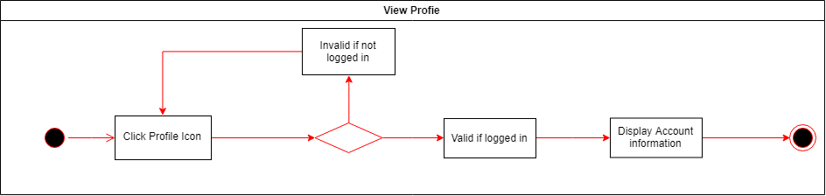

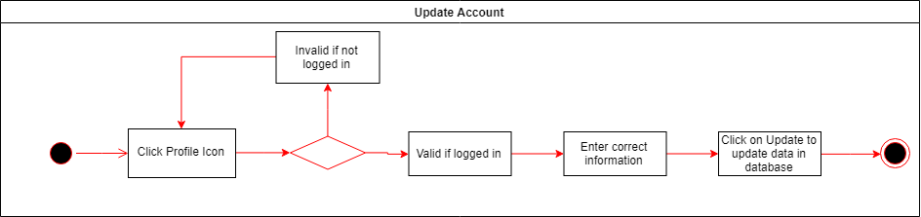

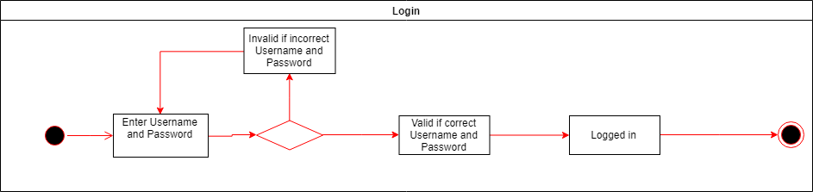

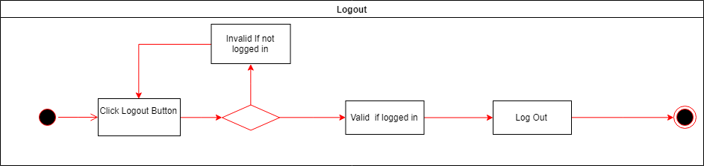

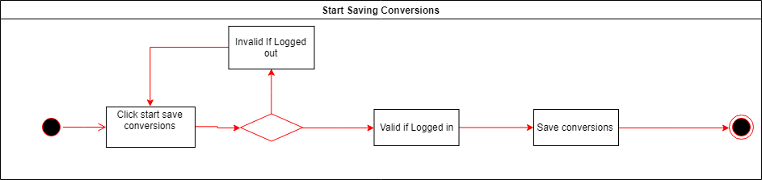

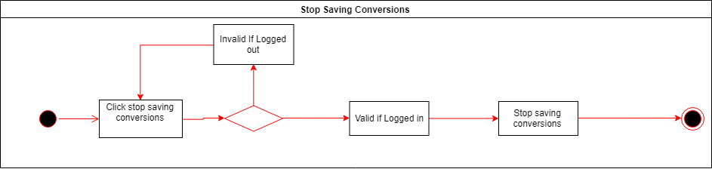

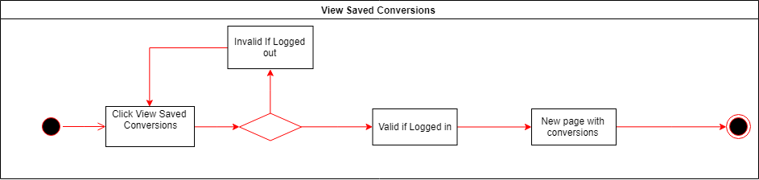

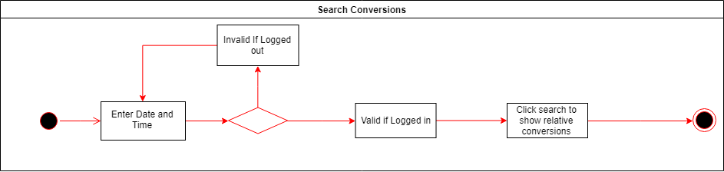

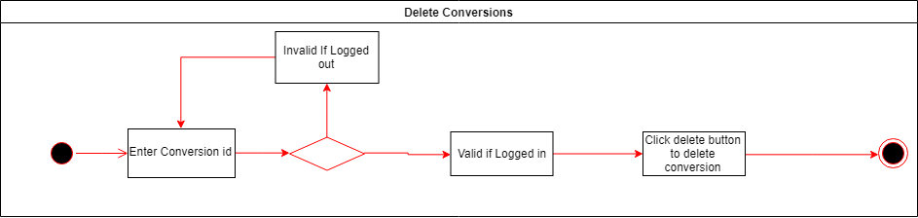

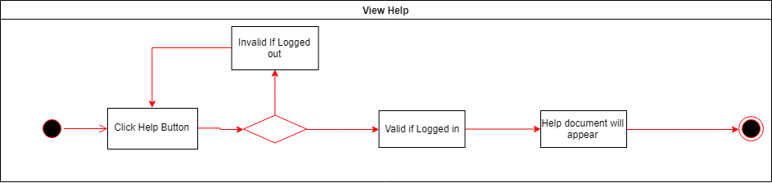

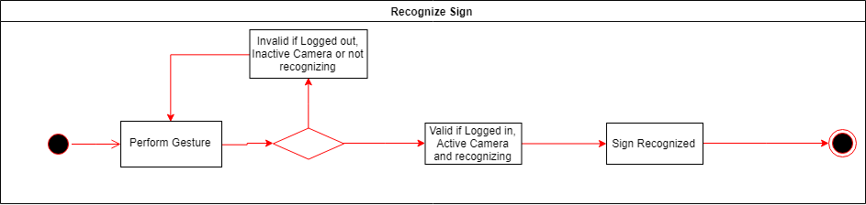

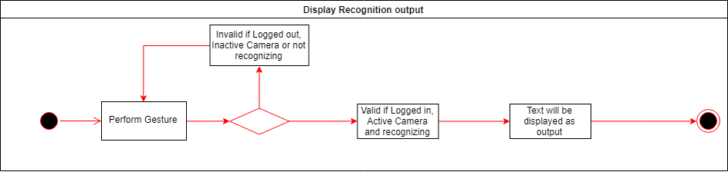

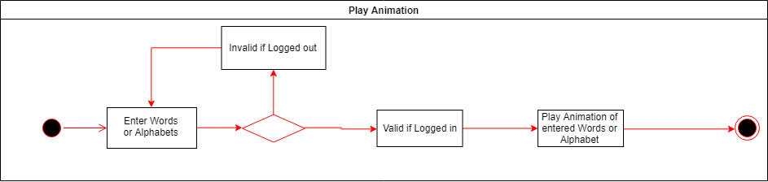

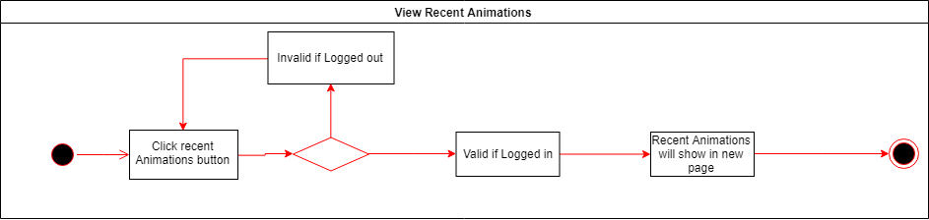

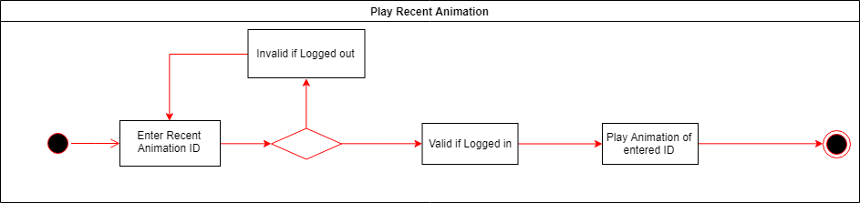

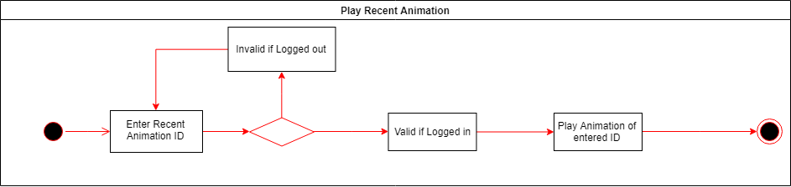

## Sequence Diagrams

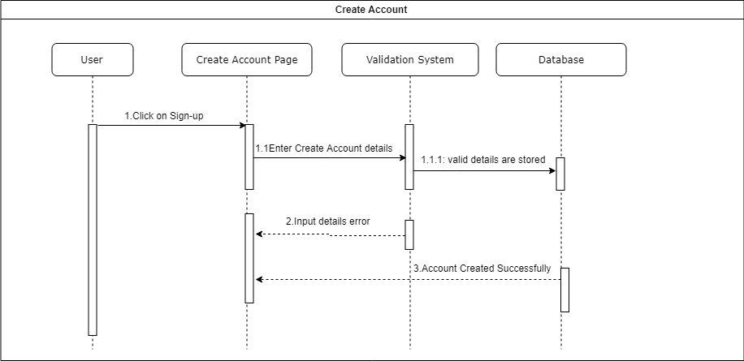

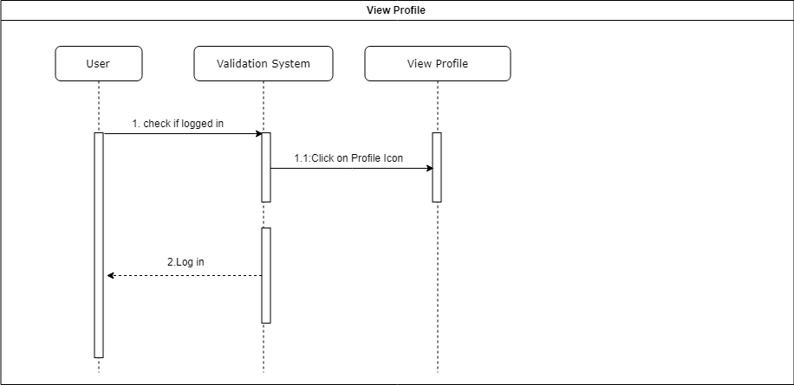

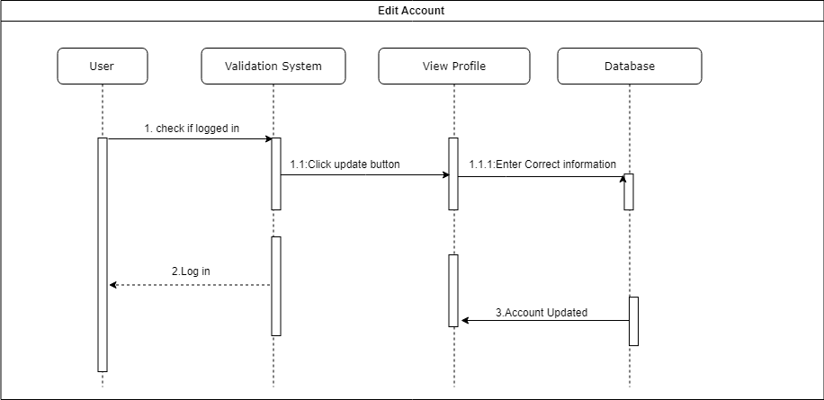

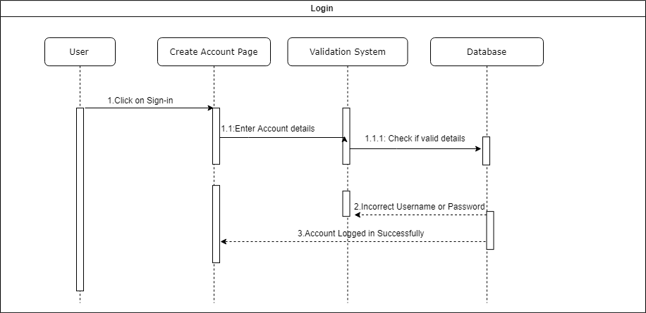

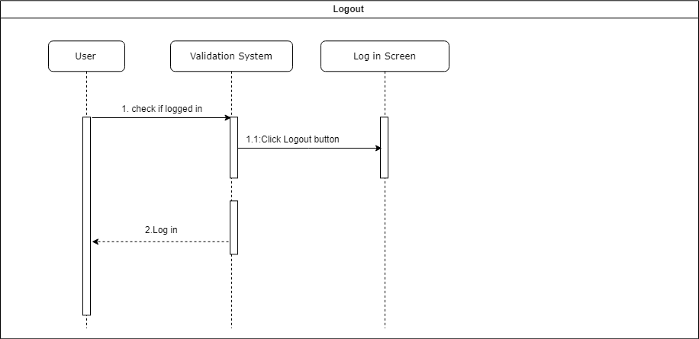

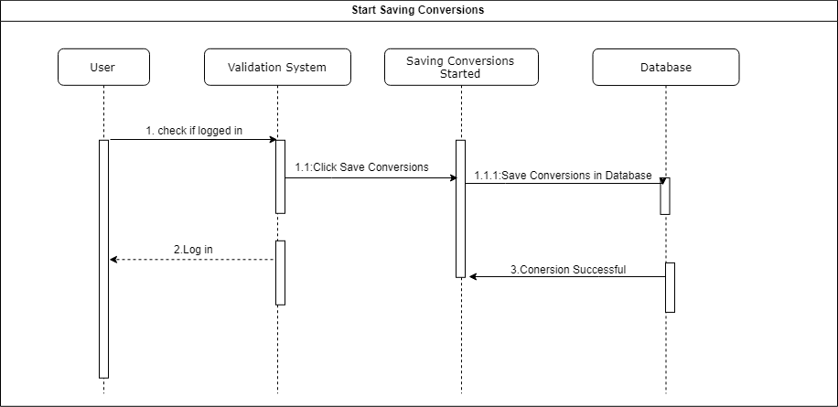

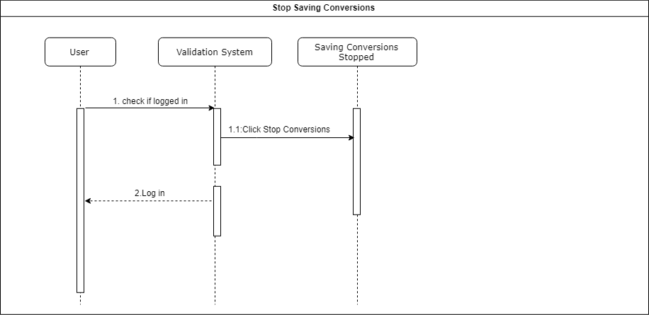

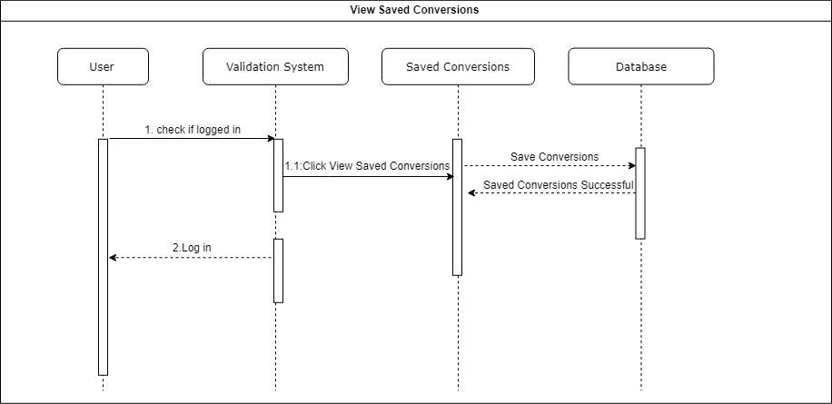

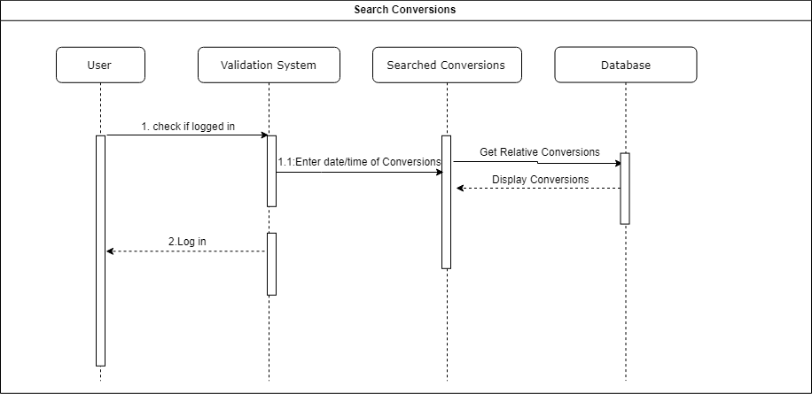

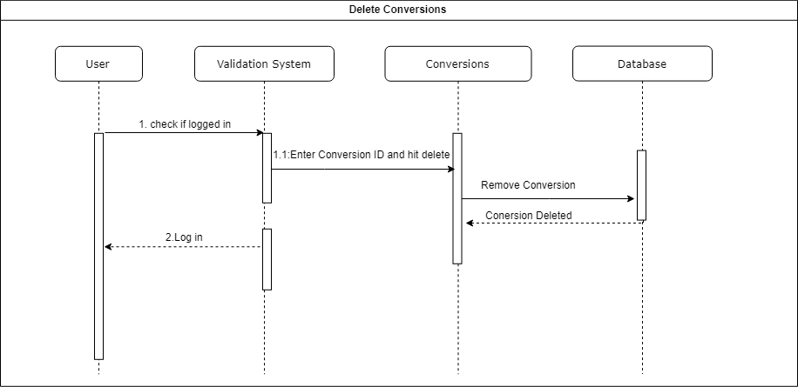

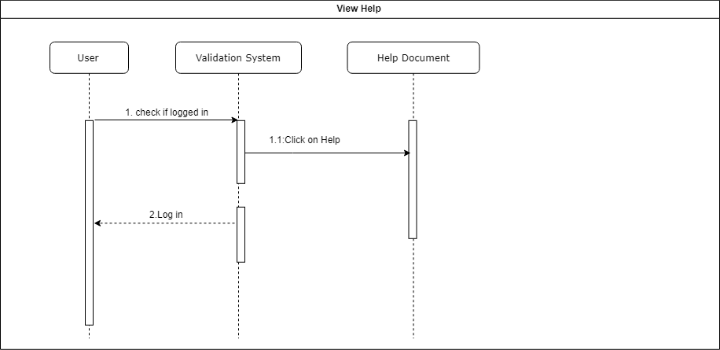

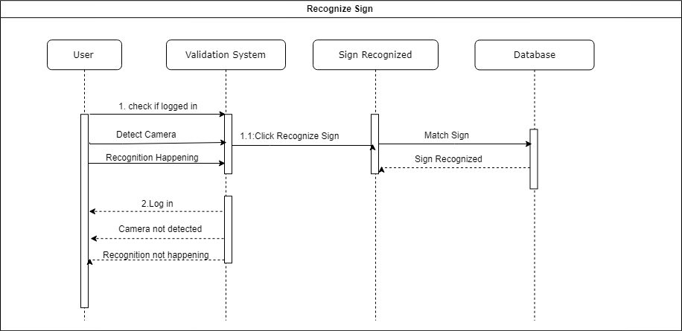

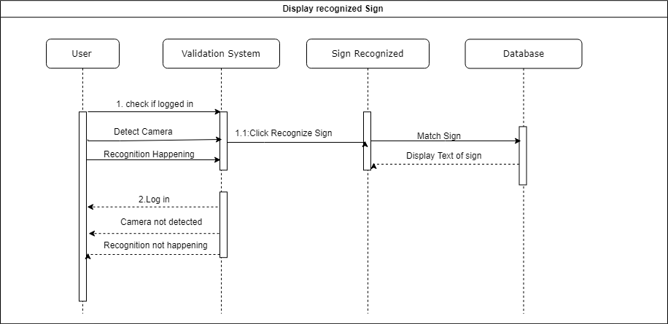

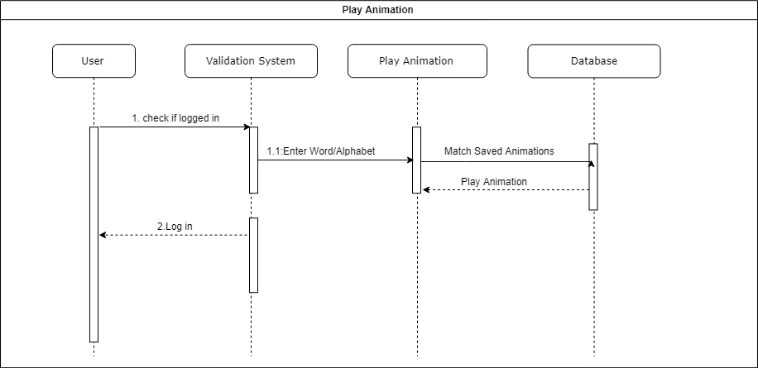

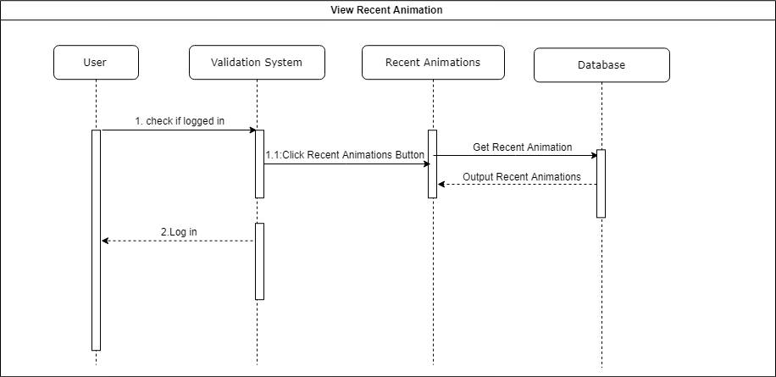

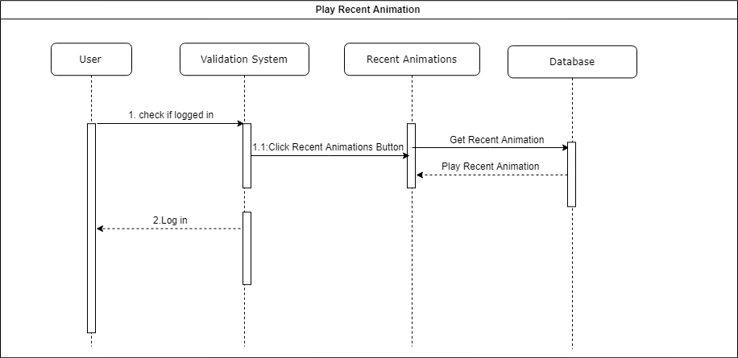

## Collaboration Diagram

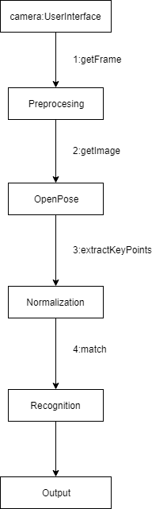

## State Transition Diagram

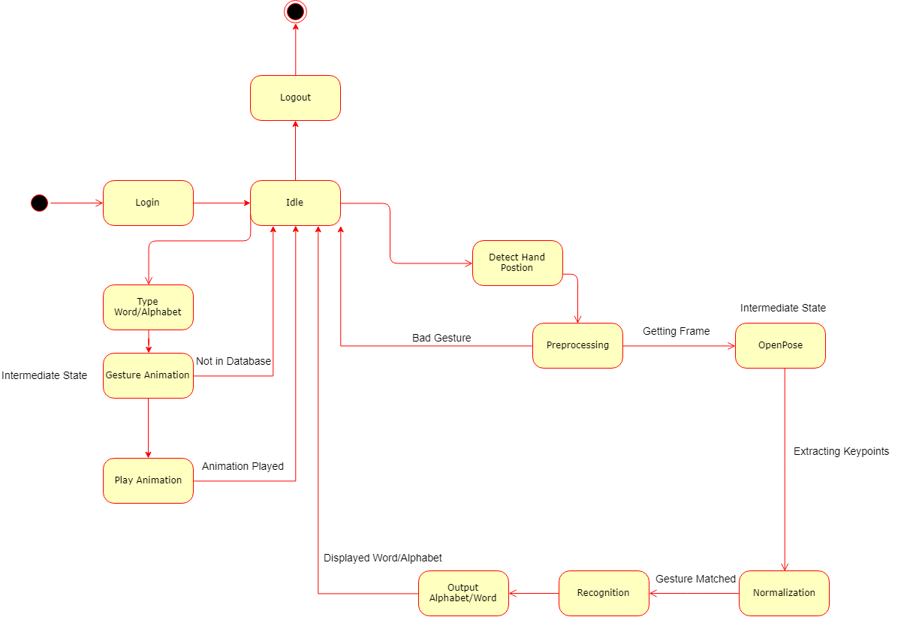

## Component Diagram

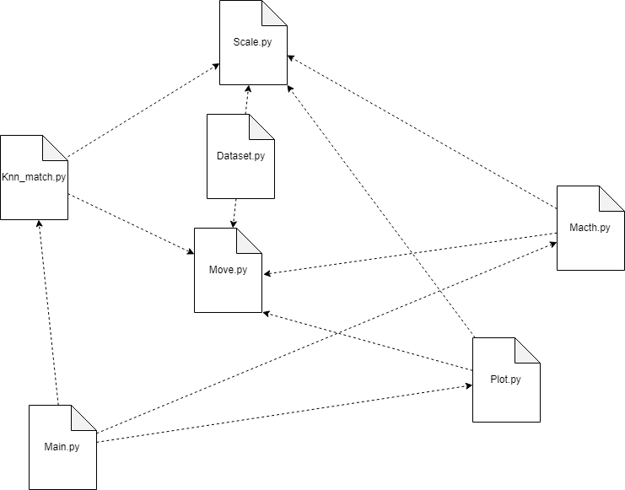

## Deployment Diagram

